BubbleSort Analysis Sheet |  |  |  |  | Modified BubbleSort Analysis Sheet
Number List Size | 10 100 1000 | 10000 | 100000 | 1000000 | Number List Size | 10 100 1000 | 10000 | 100000 | 1000000
Miliseconds 0 0 27 312 30720 3430563 Miliseconds 1 1 24 362 29499 3620412
Swaps 24 2765 246734 25026299 2481035035 247375710056 Swaps 24 2765 246734 25026299 2481035035 247375710056
Comparisons 45 4950 499500 49995000 4999950000 499999500000 Comparisons 44 4935 498275 49980122 4999889622 499997960865

Modified Graphs: Analysis:
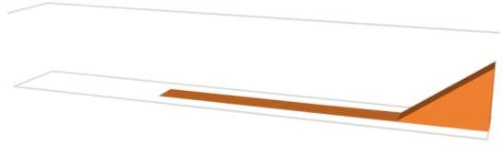
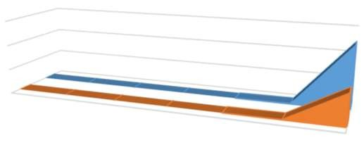
For the ModifiedBubbleSort I added a boolean feature that would skip checking over already placed numbers. Based on the data, there seems to be an overall increase in time taken but a decrease in comparisons. The swap numbers stayed the same. The times fluctuate between being faster and slower (with the times at 1000 and 100000 being faster). It's unsurprising that the swaps stayed the same, since it's the same number lists with the same amounts. The good news is that overall the comparison numbers were lower. So if this program was run on a computer with a higher processing power, I feel it may run much faster and the times may be better than what I got. It's definitely an improvement to the algorithm.
Swaps/Comparisons Based On List Size
6E+11
4E+11
2E+11
0
10
100
1000
10000
Comparisons
Swaps
100000
1000000
Number List Size
Swaps Comparisons
Miliseconds
Number List Size
1000000
100000
10000
1000
100
10
0
5000000
Milliseconds Taken Based On List Size
Swaps/Comparisons
Milliseconds
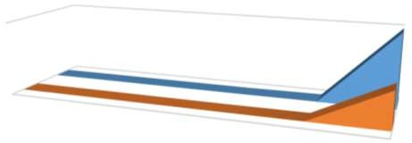
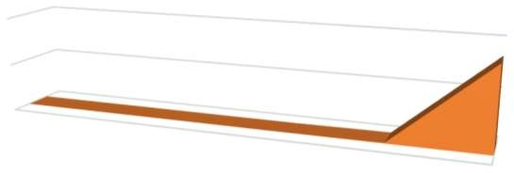
Original Graphs:
Miliseconds
Number List Size
1000000
100000
10000
Miliseconds
1000
100
10
4000000

2000000

0
Miliseconds Taken Based on List Size
Swaps Comparisons
Number List Size
1000000
100000
10000
Comparisons
Swaps
1000
100
10
0
500000000000
Comparison & Swap Numbers Based on List Size
Number of Comparisons/Swaps
Miliseconds

